**Agentie de turism**

CREATE TABLE `clienti_agentie` (

  `cod_clienti` int(7) NOT NULL,

  `cod_rezervari` int(7) NOT NULL,

  `nume_clienti` varchar(50) NOT NULL,

  `prenume_clienti` varchar(50) NOT NULL,

  `email_clienti` varchar(50) NOT NULL,

  `telefon_clienti` char(10) NOT NULL,

  `oras_clienti` varchar(50) NOT NULL,

  `judet_clienti` varchar(50) NOT NULL

INSERT INTO `clienti_agentie` (`cod_clienti`, `cod_rezervari`, `nume_clienti`, `prenume_clienti`, `email_clienti`, `telefon_clienti`, `oras_clienti`, `judet_clienti`) VALUES

(516, 1006, 'Vladu', 'Anca', 'ancavladu79@yahoo.com', '0769841265', 'Sibiu', 'Sibiu'),

(1001, 201, 'Popescu', 'Simona', 'popescusimona99@yahoo.com', '0721356987', 'Craiova', 'Dolj'),

(1002, 512, 'Popa', 'Andreea', 'popaluminita76@yahoo.com', '0765221489', 'Constanta', 'Constanta'),

(1003, 513, 'Iordache', 'Alexandra', 'iordachealexandra98@yahoo.com', '0754886532', 'Slatina', 'Olt'),

(1004, 514, 'Radulescu', 'Florin', 'florinradulescu97@yahoo.com', '0769874421', 'Bucuresti', 'Bucuresti'),

(1005, 515, 'Florescu', 'Alina', 'florescualina98@yahoo.com', '0732416987', 'Timisoara', 'Timis');

CREATE TABLE `rezervari` (

`cod_rezervari` int(7) NOT NULL,

`cod_pachete` int(7) NOT NULL,

`cod_clienti` int(7) NOT NULL,

`data_plecare` datetime NOT NULL,

`data_sosire` datetime NOT NULL,

`pret_rezervari` int(7) NOT NULL,

`avans_rezervari` int(7) NOT NULL

INSERT INTO `rezervari` (`cod_rezervari`, `cod_pachete`, `cod_clienti`, `data_plecare`, `data_sosire`, `pret_rezervari`, `avans_rezervari`) VALUES

(201, 1, 1001, '2022-06-01 17:31:24', '2022-06-01 17:31:24', 970, 485),

(512, 2, 1002, '2022-02-28 19:46:15', '2022-03-06 19:46:15', 5400, 10800),

(513, 3, 1003, '2022-02-24 12:48:31', '2022-02-28 12:48:31', 2320, 1160),

(514, 4, 1004, '2021-07-18 12:50:13', '2021-07-25 14:00:00', 21000, 10000),

(515, 5, 1005, '2021-12-21 12:00:00', '2022-06-01 13:00:00', 7920, 4500),

(1006, 6, 516, '2022-03-22 13:00:00', '2022-03-25 11:00:00', 4500, 1500);

--

-- Indexes for dumped tables

--

--

-- Indexes for table `clienti_agentie`

--

ALTER TABLE `clienti_agentie`

ADD PRIMARY KEY (`cod_clienti`),

ADD KEY `cod_rezervari` (`cod_rezervari`);

--

-- Indexes for table `pachete`

--

ALTER TABLE `pachete`

ADD PRIMARY KEY (`cod_pachete`),

ADD KEY `cod_clienti` (`cod_clienti`);

--

-- Indexes for table `rezervari`

--

ALTER TABLE `rezervari`

ADD PRIMARY KEY (`cod_rezervari`),

ADD KEY `cod_pachete` (`cod_pachete`,`cod_clienti`),

ADD KEY `cod_clienti` (`cod_clienti`);

--

-- AUTO_INCREMENT for dumped tables

--

--

-- AUTO_INCREMENT for table `clienti_agentie`

--

ALTER TABLE `clienti_agentie`

MODIFY `cod_clienti` int(7) NOT NULL AUTO_INCREMENT, AUTO_INCREMENT=1006;

--

-- AUTO_INCREMENT for table `pachete`

--

ALTER TABLE `pachete`

MODIFY `cod_pachete` int(7) NOT NULL AUTO_INCREMENT, AUTO_INCREMENT=7;

--

-- Constraints for dumped tables

--

--

-- Constraints for table `pachete`

--

ALTER TABLE `pachete`

ADD CONSTRAINT `pachete_ibfk_1` FOREIGN KEY (`cod_clienti`) REFERENCES `clienti_agentie` (`cod_clienti`);

--

-- Constraints for table `rezervari`

--

ALTER TABLE `rezervari`

ADD CONSTRAINT `rezervari_ibfk_1` FOREIGN KEY (`cod_pachete`) REFERENCES `pachete` (`cod_pachete`),

ADD CONSTRAINT `rezervari_ibfk_2` FOREIGN KEY (`cod_rezervari`) REFERENCES `clienti_agentie` (`cod_rezervari`),

ADD CONSTRAINT `rezervari_ibfk_3` FOREIGN KEY (`cod_clienti`) REFERENCES `clienti_agentie` (`cod_clienti`);

COMMIT;

CREATE TABLE `pachete` (

  `cod_pachete` int(7) NOT NULL,

  `cod_clienti` int(7) NOT NULL,

  `destinatie` varchar(50) NOT NULL,

  `data_inceput` datetime NOT NULL,

  `data_sfarsit` datetime NOT NULL,

  `denumire_hotel` varchar(50) NOT NULL,

  `transport` varchar(50) NOT NULL,

  `numar_persoane` varchar(50) NOT NULL,

  `numar_nopti_cazare` varchar(50) NOT NULL,

  `pret_noapte` int(7) NOT NULL

INSERT INTO `pachete` (`cod_pachete`, `cod_clienti`, `destinatie`, `data_inceput`, `data_sfarsit`, `denumire_hotel`, `transport`, `numar_persoane`, `numar_nopti_cazare`, `pret_noapte`) VALUES

(1, 1001, 'Mamaia', '2022-05-10 12:39:53', '2022-05-14 14:08:23', 'Iaki', 'masina personala', '2', '4', 485),

(2, 1002, 'Barcelona', '2022-02-28 12:12:59', '2022-03-06 13:12:59', 'La Rambla', 'avion', '2', '6', 900),

(3, 1003, 'Londra', '2022-02-24 16:15:14', '2022-02-28 12:00:00', 'Ritz London', 'avion', '2', '3', 580),

(4, 1005, 'Lisabona', '2021-07-18 15:30:51', '2021-07-25 12:08:51', 'Lisboa Bon Dia', 'avion', '4', '7', 750),

(5, 1004, 'Brasov', '2021-12-21 14:11:12', '2021-12-23 11:10:12', 'Alpin', 'masina personala', '6', '2', 660),

(6, 516, 'Milano', '2022-03-22 17:13:21', '2022-03-25 12:20:21', 'Milano Grande Italia', 'avion', '3', '3', 150);

Operatia de filtrare;

[SELECT](http://localhost/phpmyadmin/url.php?url=https://dev.mysql.com/doc/refman/8.0/en/select.html) * FROM `pachete` WHERE `pret_noapte` ='580';

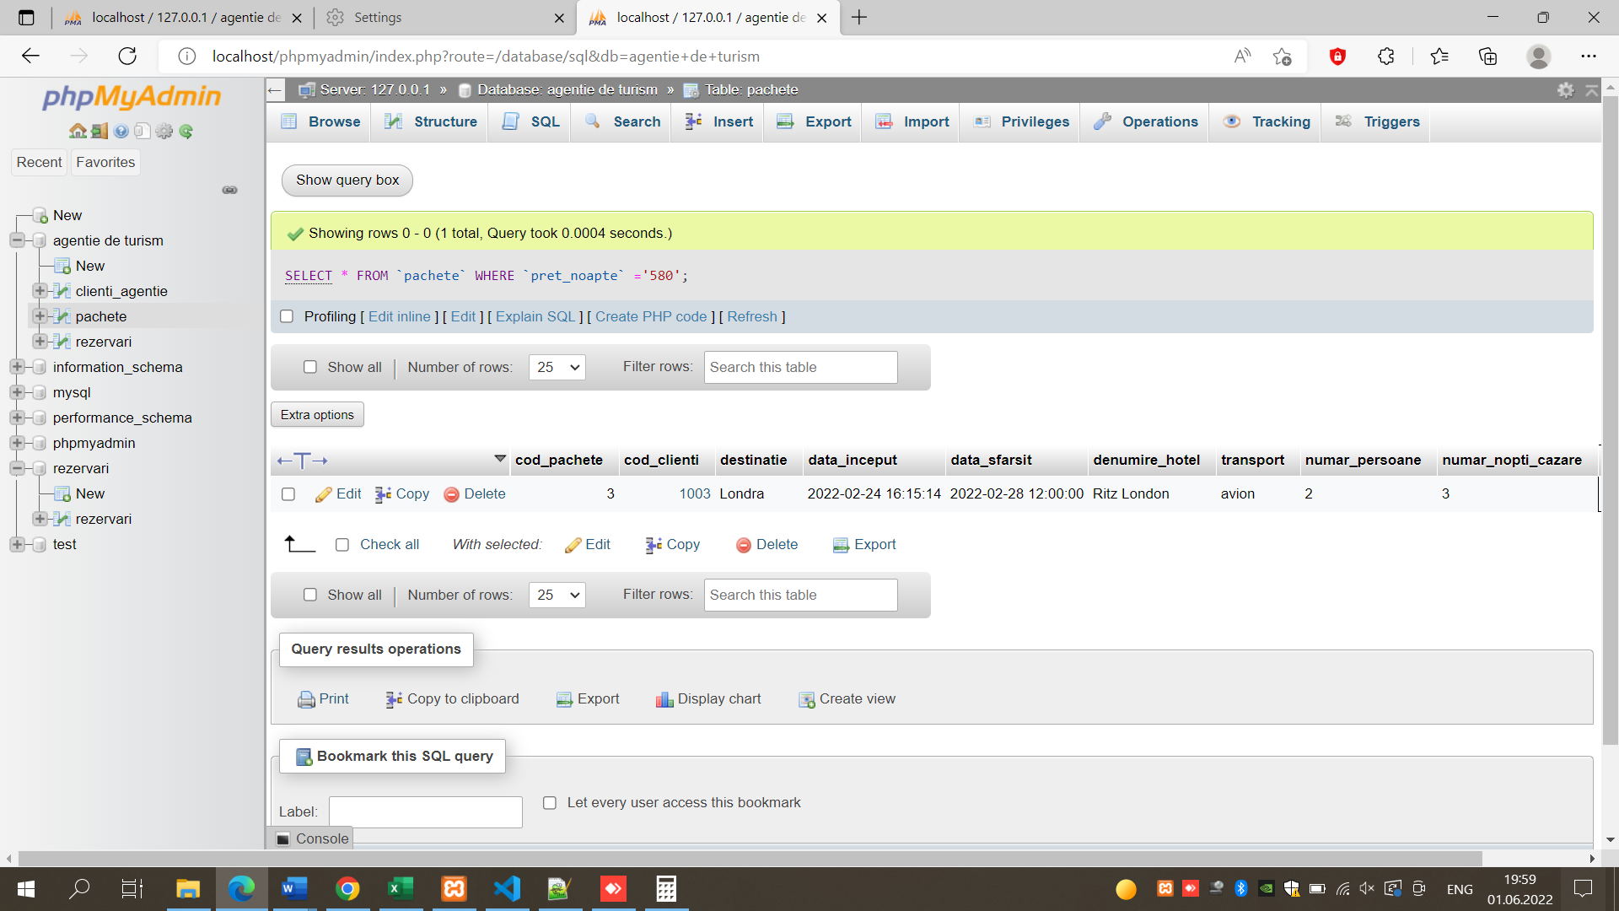

OPERATIA DE SORTARE;

[SELECT](http://localhost/phpmyadmin/url.php?url=https://dev.mysql.com/doc/refman/8.0/en/select.html) * FROM `pachete` ORDER BY `denumire_hotel` ASC;

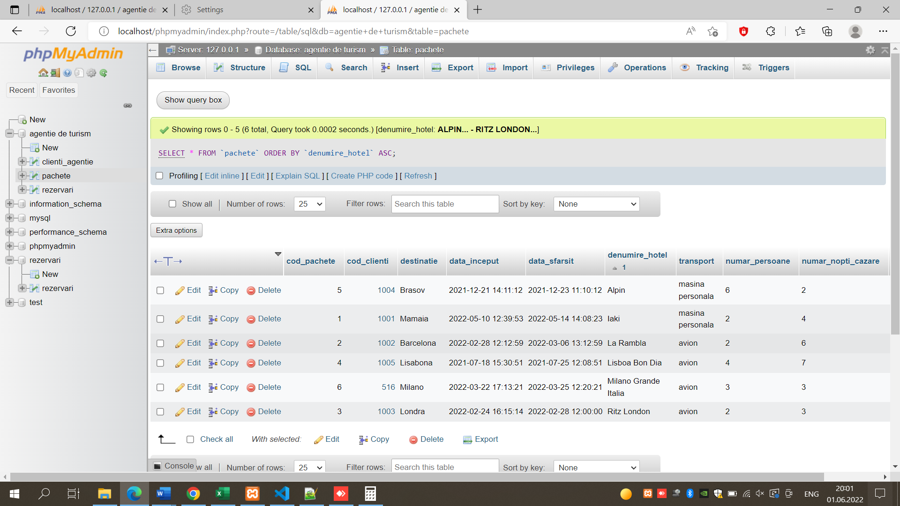

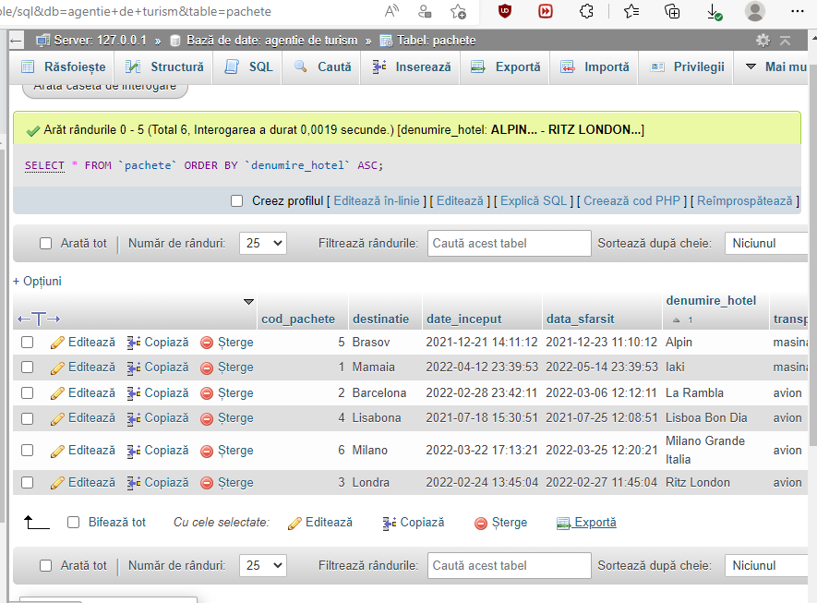

INTEROGARE PRIN PSEUDONIME;

[SELECT](http://localhost/phpmyadmin/url.php?url=https://dev.mysql.com/doc/refman/8.0/en/select.html) * FROM `pachete` WHERE `denumire_hotel` = 'Iaki';

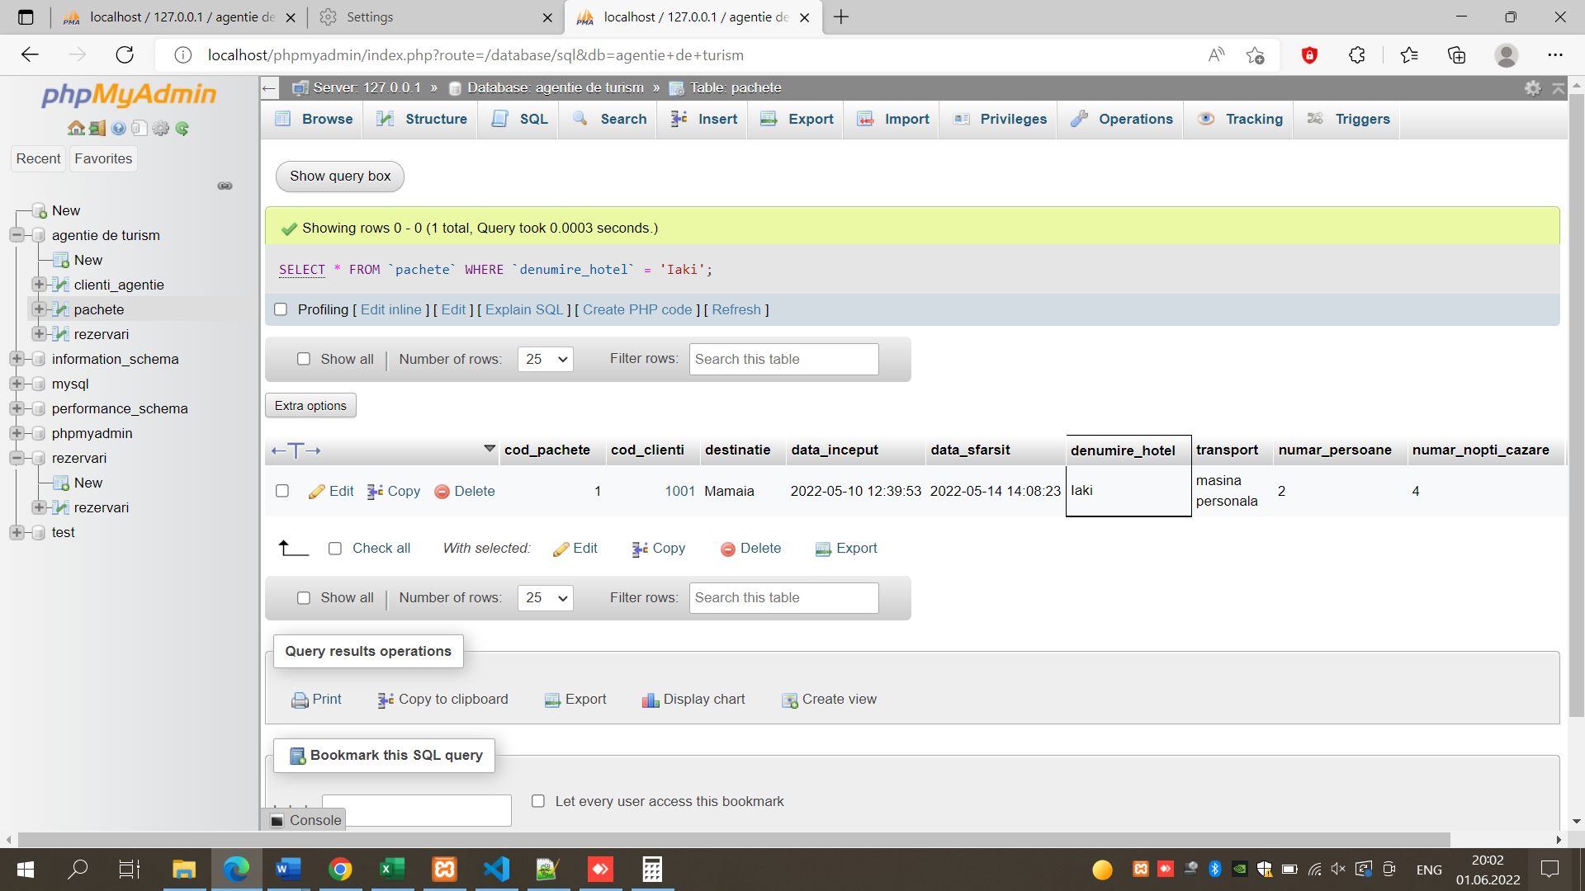

Operatia de comparare;

[SELECT](http://localhost/phpmyadmin/url.php?url=https://dev.mysql.com/doc/refman/8.0/en/select.html) `pret_noapte` AS PRET, `destinatie`FROM `pachete` WHERE `pret_noapte` = '750';

OPERATORUL LIKE;

[SELECT](http://localhost/phpmyadmin/url.php?url=https://dev.mysql.com/doc/refman/8.0/en/select.html) `denumire_hotel` FROM `pachete` WHERE `denumire_hotel` [LIKE](http://localhost/phpmyadmin/url.php?url=https://dev.mysql.com/doc/refman/8.0/en/string-comparison-functions.html%23operator_like) '%RI%';

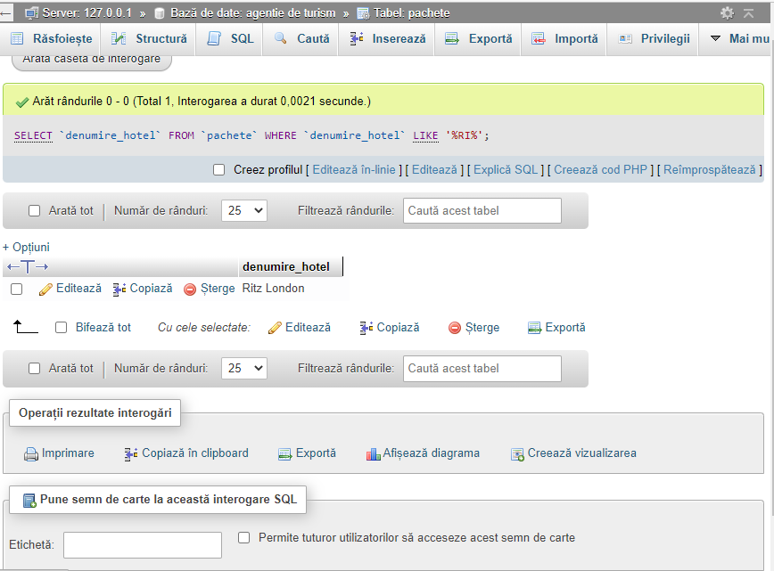

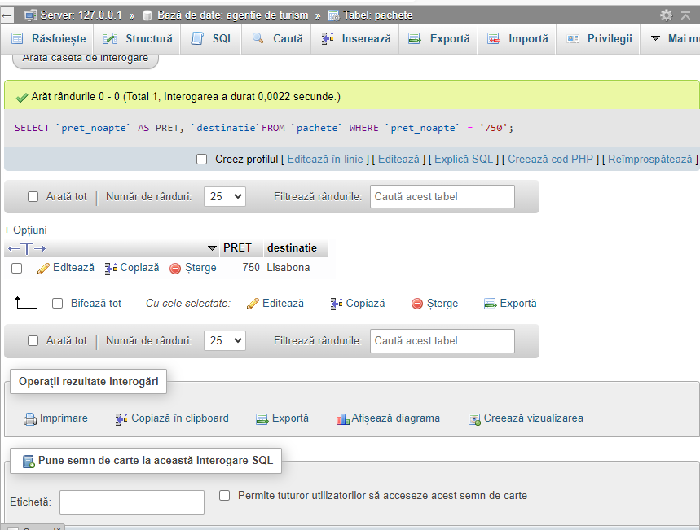

OPERATORI LOGICI;

[SELECT](http://localhost/phpmyadmin/url.php?url=https://dev.mysql.com/doc/refman/8.0/en/select.html) `denumire_hotel` AS HOTEL,`pret_noapte` AS PRET, `destinatie` FROM `pachete` WHERE `pret_noapte` = '485' [AND](http://localhost/phpmyadmin/url.php?url=https://dev.mysql.com/doc/refman/8.0/en/logical-operators.html%23operator_and) `pret_noapte` <= '660' ORDER BY `pret_noapte`;

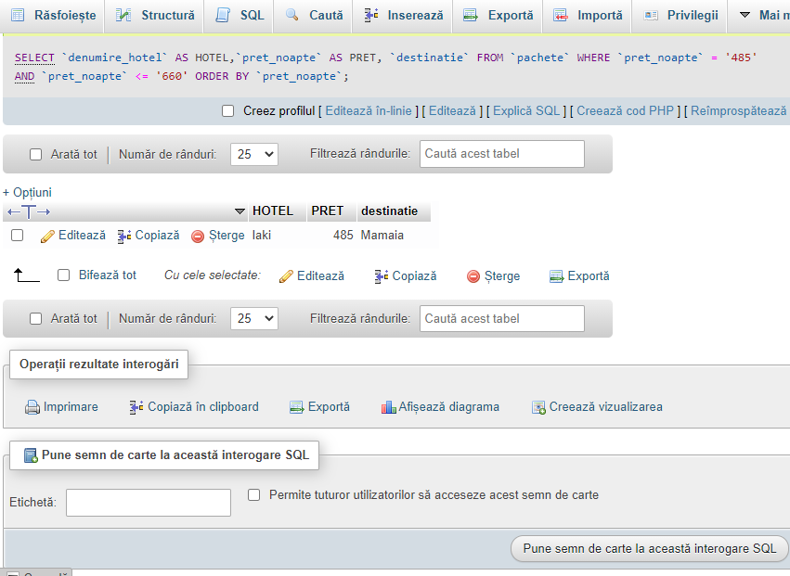

OPERATORUL NULL;

[SELECT](http://localhost/phpmyadmin/url.php?url=https://dev.mysql.com/doc/refman/8.0/en/select.html) `destinatie` FROM `pachete` WHERE `pret_noapte` [IS](http://localhost/phpmyadmin/url.php?url=https://dev.mysql.com/doc/refman/8.0/en/comparison-operators.html%23operator_is) NULL;

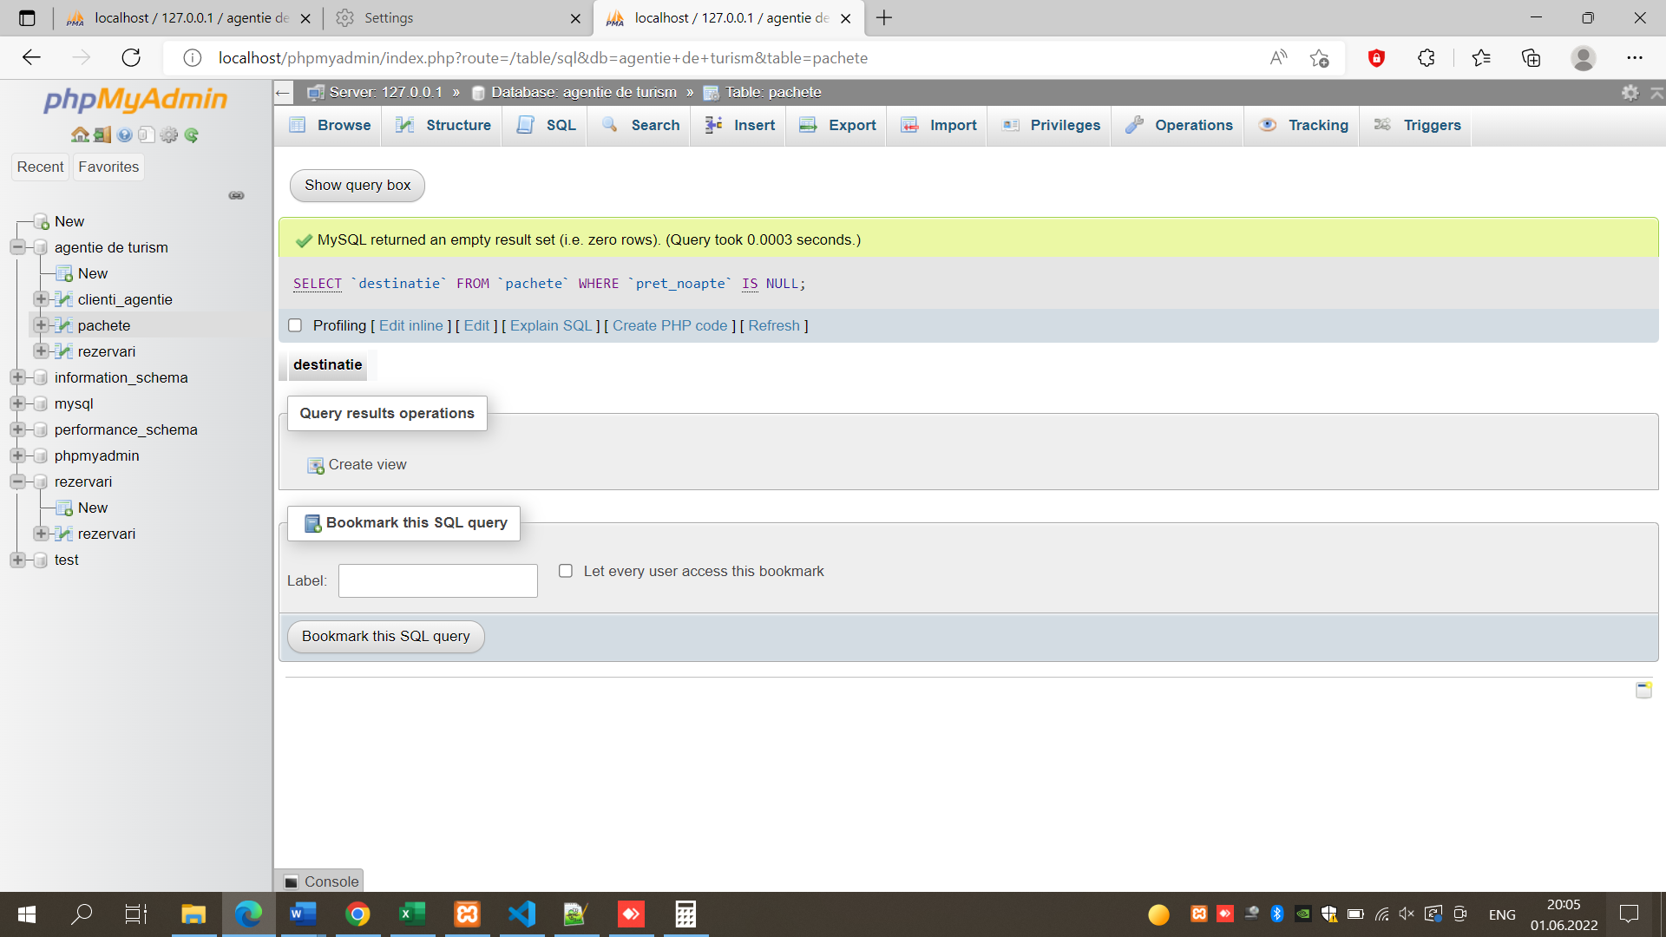

OPERATORUL BETWEEN;

[SELECT](http://localhost/phpmyadmin/url.php?url=https://dev.mysql.com/doc/refman/8.0/en/select.html) `cod_pachete`, `destinatie` ,`denumire_hotel`,`pret_noapte` FROM `pachete` WHERE `pret_noapte` BETWEEN 650 [AND](http://localhost/phpmyadmin/url.php?url=https://dev.mysql.com/doc/refman/8.0/en/logical-operators.html%23operator_and) 900 ORDER BY `pret_noapte`;

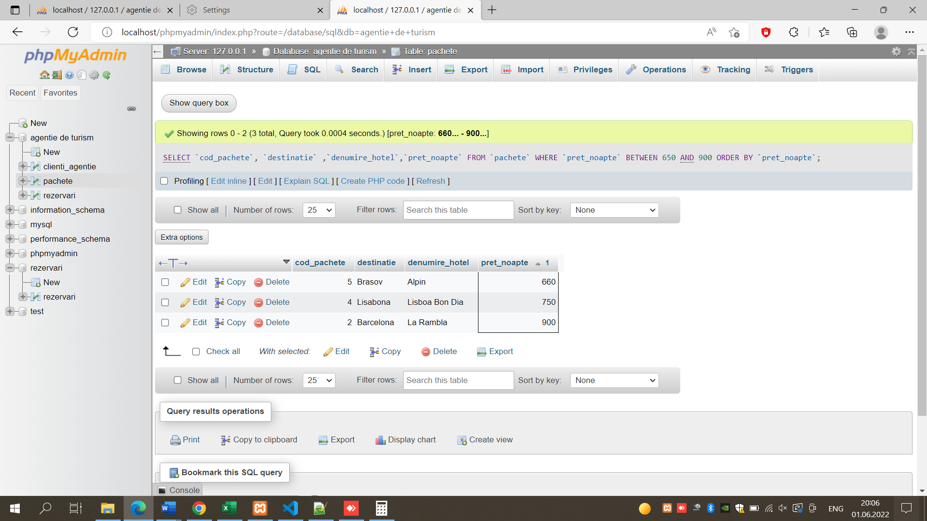

FUNCTII PENTRU CARACTERE;

[SELECT](http://localhost/phpmyadmin/url.php?url=https://dev.mysql.com/doc/refman/8.0/en/select.html) UPPER(`denumire_hotel`) AS 'DENUMIRE HOTEL' FROM `pachete` WHERE `destinatie` = 'Lisabona';

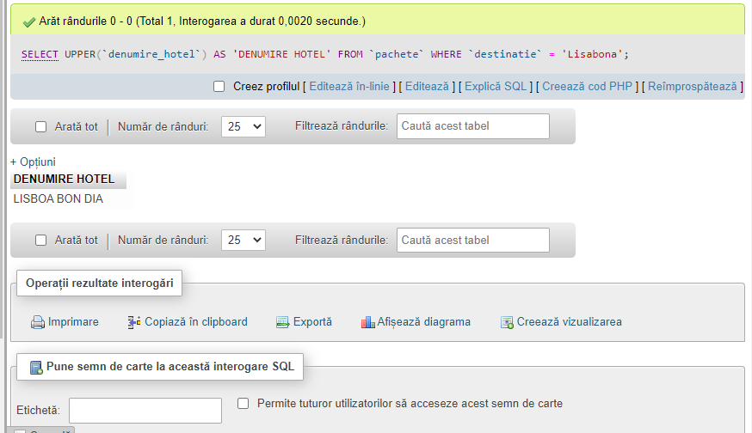

FUNCTII DE AGREGARE ;

[SELECT](http://localhost/phpmyadmin/url.php?url=https://dev.mysql.com/doc/refman/8.0/en/select.html) ROUND ([AVG](http://localhost/phpmyadmin/url.php?url=https://dev.mysql.com/doc/refman/8.0/en/aggregate-functions.html%23function_avg) (`pret_noapte`),2) AS AVG_PRET FROM `pachete`;

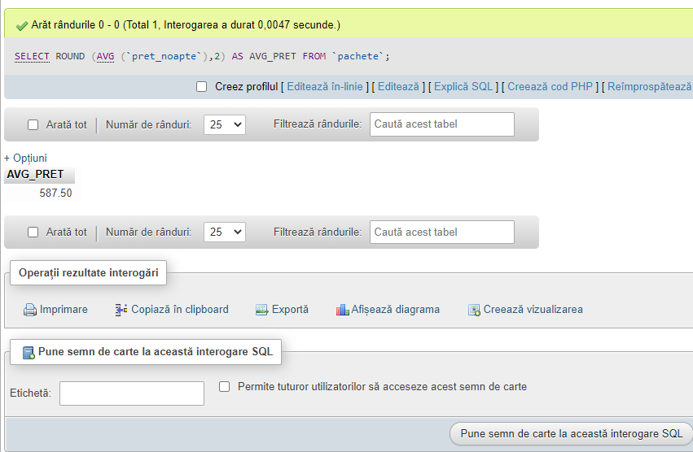

CLAUZA GROUP BY;

[SELECT](http://localhost/phpmyadmin/url.php?url=https://dev.mysql.com/doc/refman/8.0/en/select.html) `denumire_hotel` AS HOTEL, [COUNT](http://localhost/phpmyadmin/url.php?url=https://dev.mysql.com/doc/refman/8.0/en/aggregate-functions.html%23function_count)(*) AS [COUNT](http://localhost/phpmyadmin/url.php?url=https://dev.mysql.com/doc/refman/8.0/en/aggregate-functions.html%23function_count) FROM `pachete` GROUP BY `denumire_hotel`;

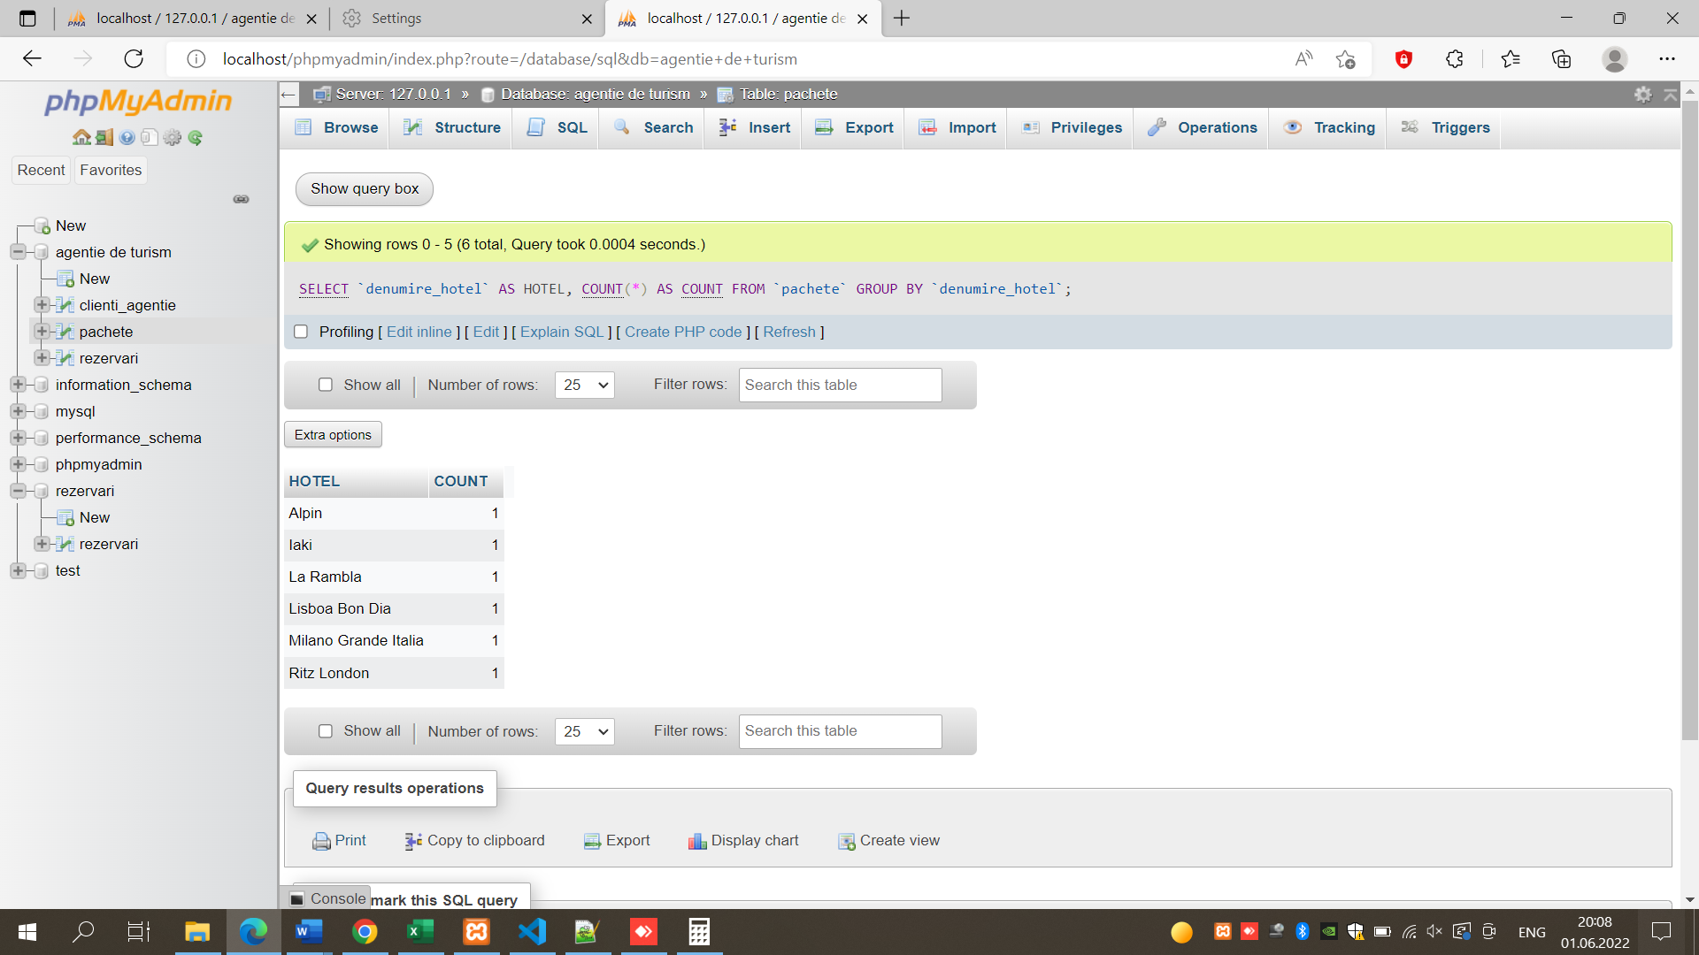

FUNCTII MATEMATICE ;

[SELECT](http://localhost/phpmyadmin/url.php?url=https://dev.mysql.com/doc/refman/8.0/en/select.html) ROUND ([AVG](http://localhost/phpmyadmin/url.php?url=https://dev.mysql.com/doc/refman/8.0/en/aggregate-functions.html%23function_avg)(`pret_rezervari` + `avans_rezervari`),2) AS AVG_COST FROM `rezervari` WHERE `cod_pachete`= '1';

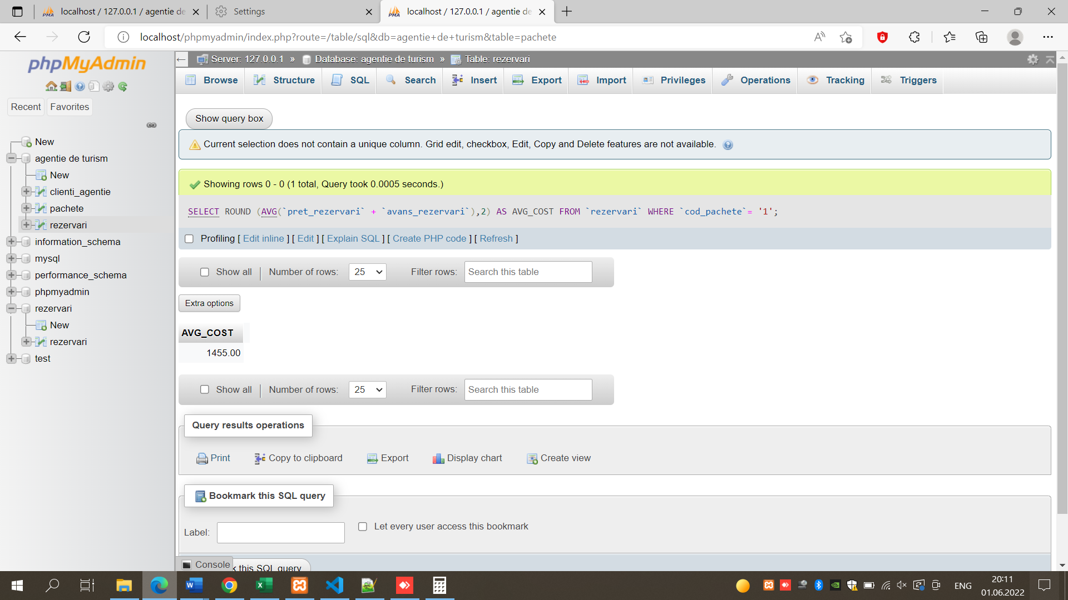

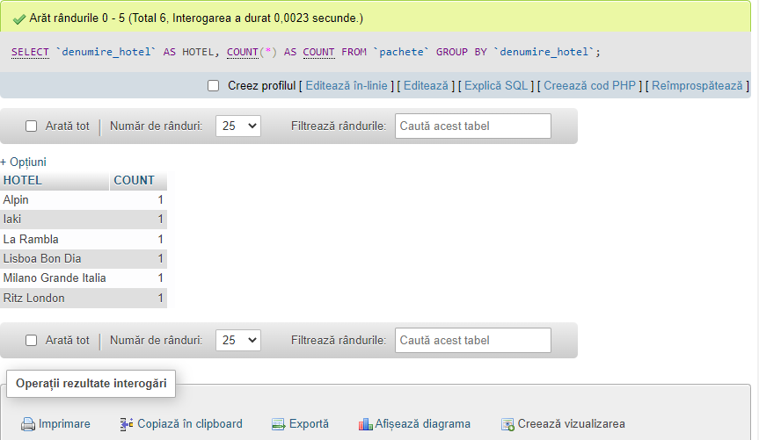

INTEROGARI AVANSATE;

FUNCTIA REPLACE;

[SELECT](http://localhost/phpmyadmin/url.php?url=https://dev.mysql.com/doc/refman/8.0/en/select.html) TELEFON_CLIENTI, [REPLACE](http://localhost/phpmyadmin/url.php?url=https://dev.mysql.com/doc/refman/8.0/en/replace.html) (TELEFON_CLIENTI, '-','.') AS TELEFON FROM CLIENTI_AGENTIE;

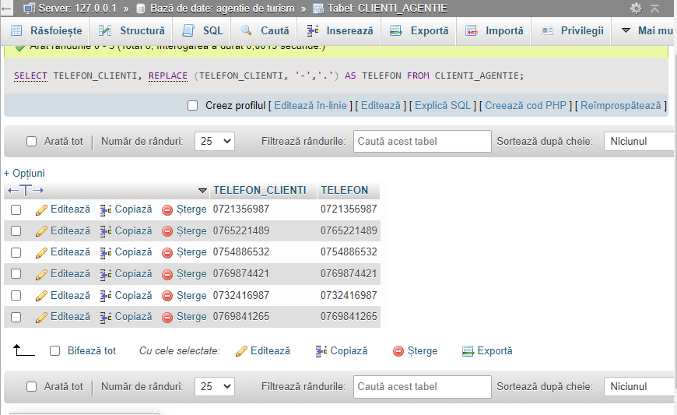

FUNCTIA FLOOR:

[SELECT](http://localhost/phpmyadmin/url.php?url=https://dev.mysql.com/doc/refman/8.0/en/select.html) PRET_REZERVARI,FLOOR(PRET_REZERVARI) AS PRET FROM rezervari WHERE PRET_REZERVARI [IS](http://localhost/phpmyadmin/url.php?url=https://dev.mysql.com/doc/refman/8.0/en/comparison-operators.html%23operator_is) [NOT](http://localhost/phpmyadmin/url.php?url=https://dev.mysql.com/doc/refman/8.0/en/logical-operators.html%23operator_not) NULL;

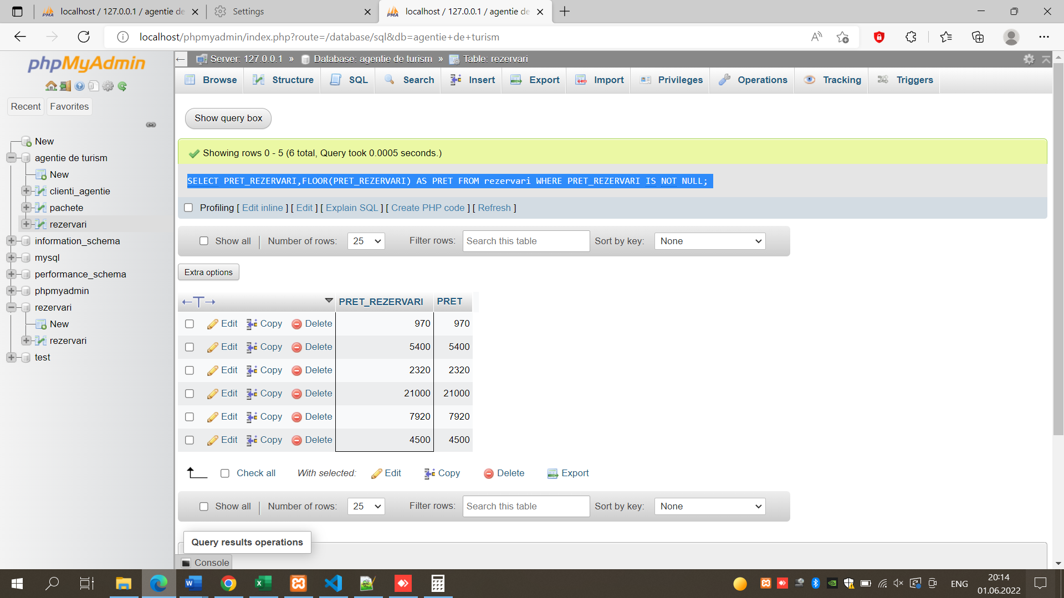

FUNCTIA CEILING

[SELECT](http://localhost/phpmyadmin/url.php?url=https://dev.mysql.com/doc/refman/8.0/en/select.html) PRET_REZERVARI,CEILING(PRET_REZERVARI) AS PRET FROM REZERVARI WHERE PRET_REZERVARI [IS](http://localhost/phpmyadmin/url.php?url=https://dev.mysql.com/doc/refman/8.0/en/comparison-operators.html%23operator_is) [NOT](http://localhost/phpmyadmin/url.php?url=https://dev.mysql.com/doc/refman/8.0/en/logical-operators.html%23operator_not) NULL;

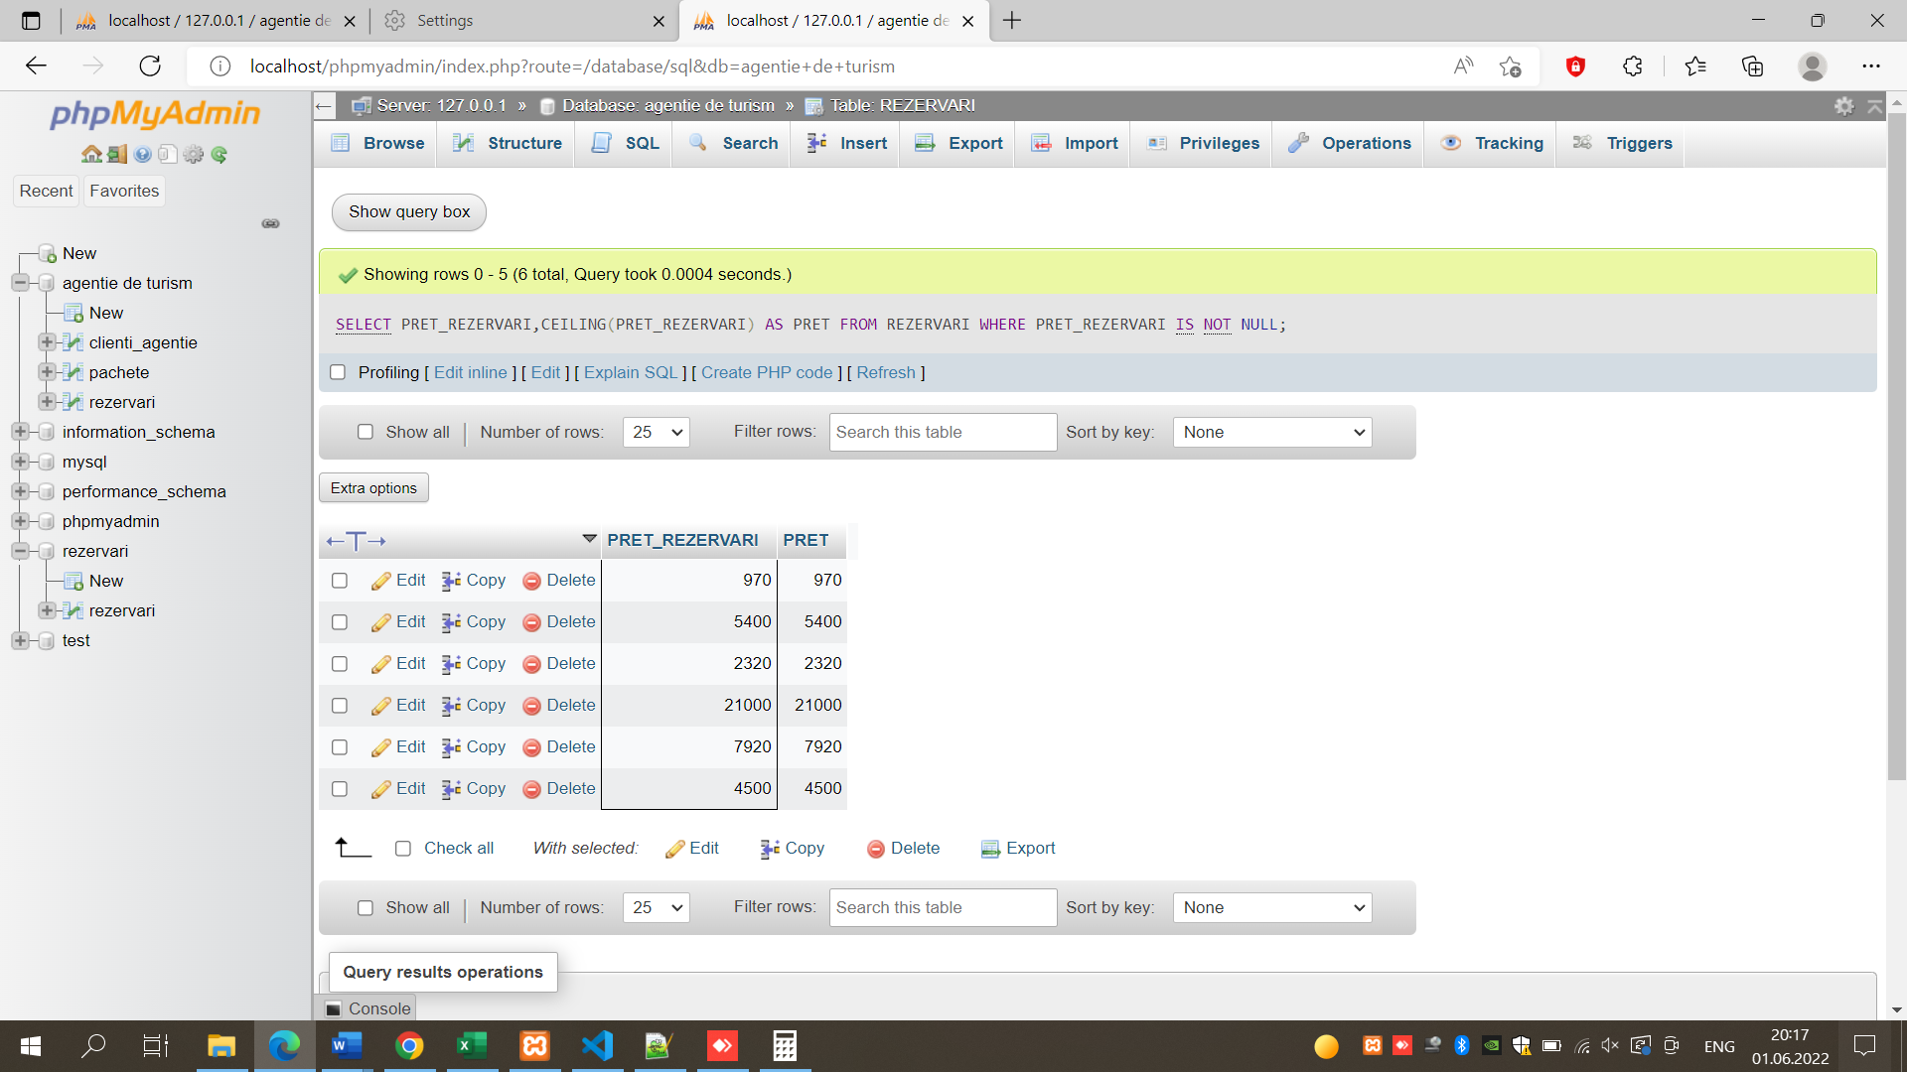

FUNCTIA SQRT:

[SELECT](http://localhost/phpmyadmin/url.php?url=https://dev.mysql.com/doc/refman/8.0/en/select.html) PRET_REZERVARI,SQRT(PRET_REZERVARI) AS PRET FROM REZERVARI WHERE PRET_REZERVARI [IS](http://localhost/phpmyadmin/url.php?url=https://dev.mysql.com/doc/refman/8.0/en/comparison-operators.html%23operator_is) [NOT](http://localhost/phpmyadmin/url.php?url=https://dev.mysql.com/doc/refman/8.0/en/logical-operators.html%23operator_not) NULL;

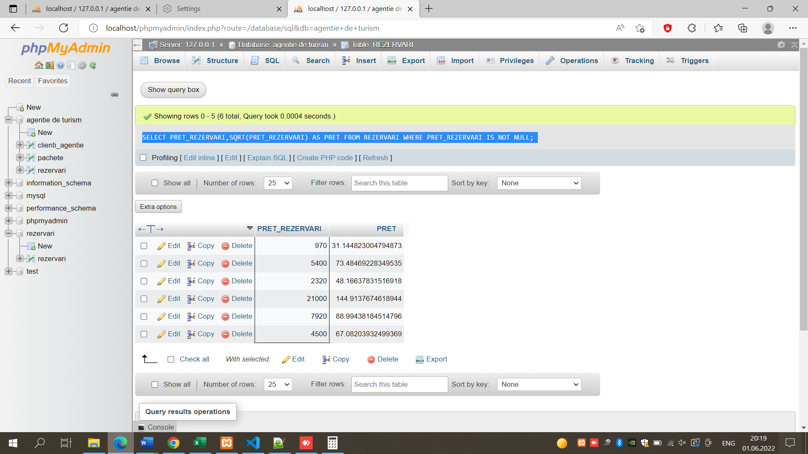

INNER JOIN:

[SELECT](http://localhost/phpmyadmin/url.php?url=https://dev.mysql.com/doc/refman/8.0/en/select.html) NUME_CLIENTI, PRENUME_CLIENTI FROM clienti_agentie INNER JOIN PACHETE USING (COD_CLIENTI);

